Formal Review Sprint 4
Requester Name: Mark Roberts
Reviewer Name: Jonathan Maronde
Date of Review: 4/28
Review Type (e.g., code, usability, design, other): code and design

Scope:
Artifact Reviewed: Dockerfile, docker-compose.yaml, SettingsPage.tsk, UserProfilePage.tsk
Review Objectives: make sure code is readable, comments are throughout, and

Methodology:
Approach Taken (e.g., execute, inspect, observe): observe how the code works on the site and inspect it for readability and best practices.
Evaluation Criteria (e.g., expected behavior, best practices, heuristic evaluation): expected behavior and best practices.
Coverage / Limitations (e.g., test login only, ignore database integration): watching mark do it on his machine.

Findings
Strengths:
- Code works
- Code is readable
- comments are included throughout
- frontend is very organized and designed well
- ai chatbot correctly makes a recipe based off my chosen preferences
- settings correctly allow me to edit allergens, metrics, preferences, etc
- profile page correctly calculates my BMI and uses it to generate appropriate recipes

Issues / Defects:
Description of Issue | Severity (Low/Med/High) | Evidence / Example | Suggested Fix
Calories don’t edit with user input (stuck at 2000) | Med |  | Check backend code to make sure the data is updateable.
Calorie recommendations should be automatically calculated when BMI is calculated. | Low | 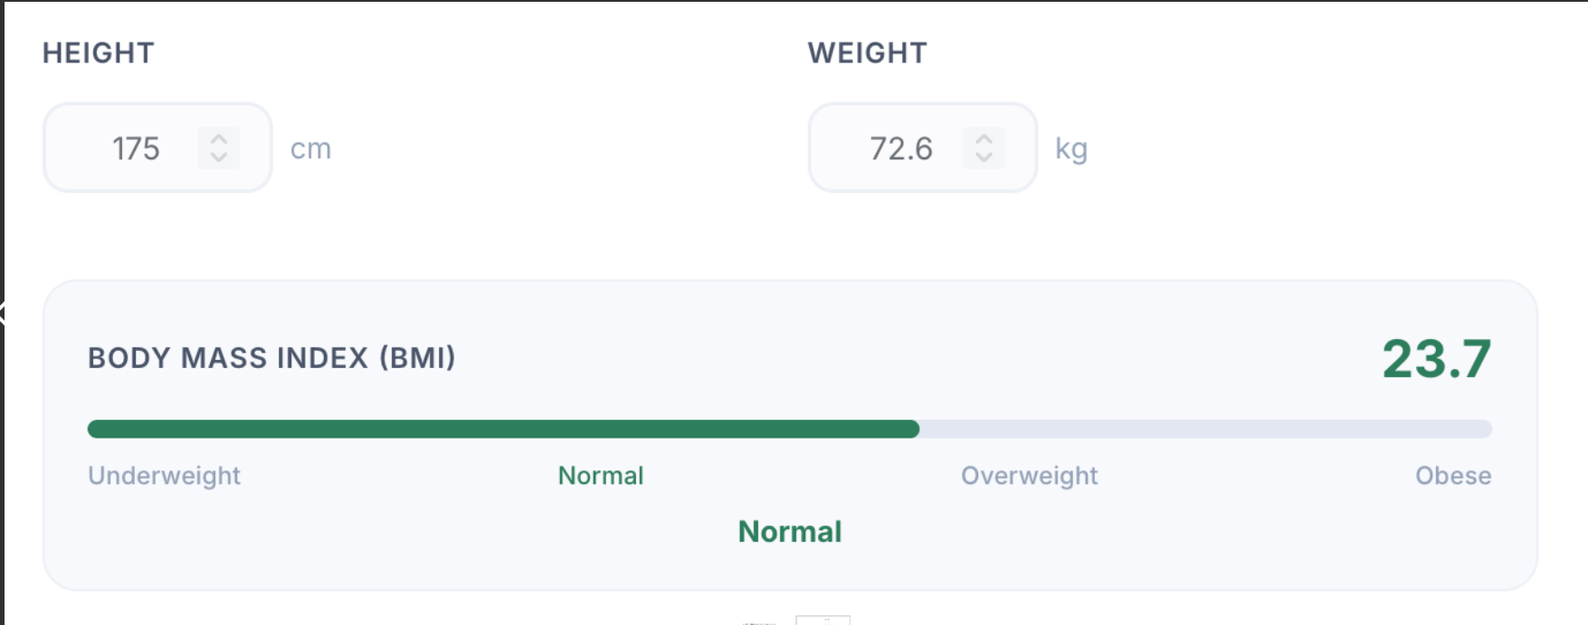 | Edit backend code to check when BMI is edited then change the calorie recommendations.

